Squad: Birth of the conflict

Units-

1. Information
2. Prologue
3. Chapter 1
4. Chapter 2
5. Chapter 3
6. Chapter 4
7. Chapter 5
8. Chapter 6
9. Sequel link

10.The End

Information

Osiris- A troop which is against the Bayn.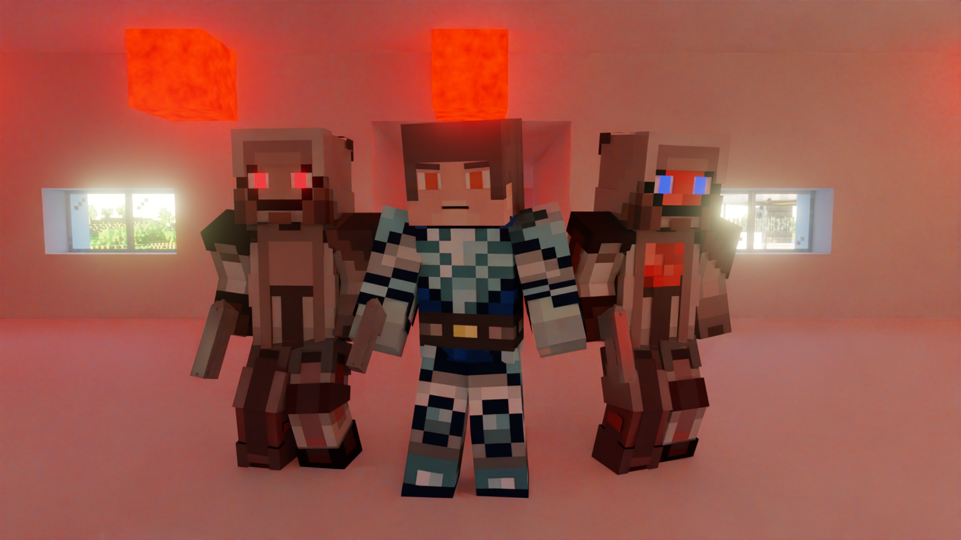

Bayn- A military group that opposes the Osiris.

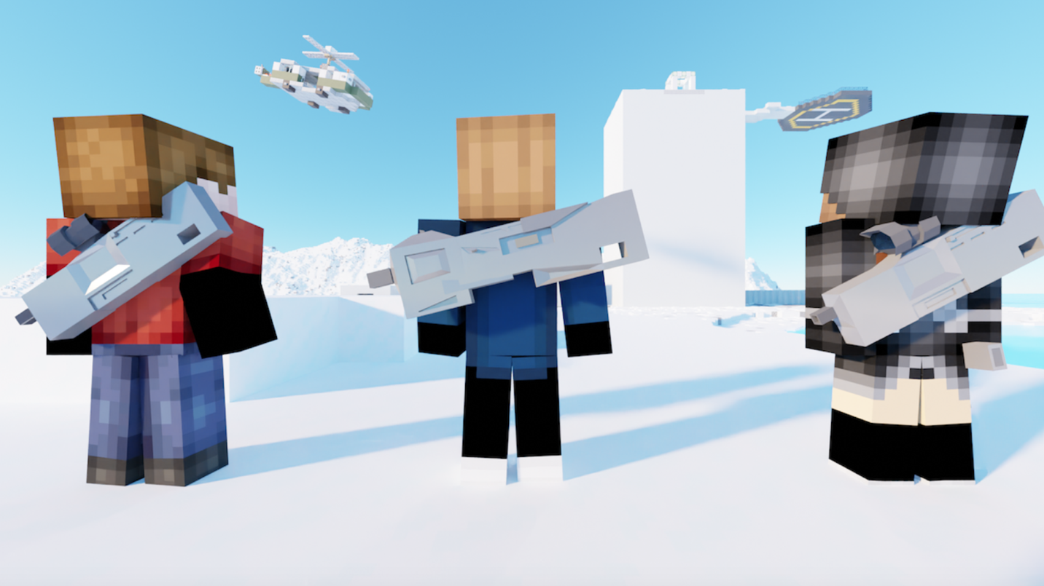

Kabe- A soldier who works for the Osiris and works alongside fireteam Orion.

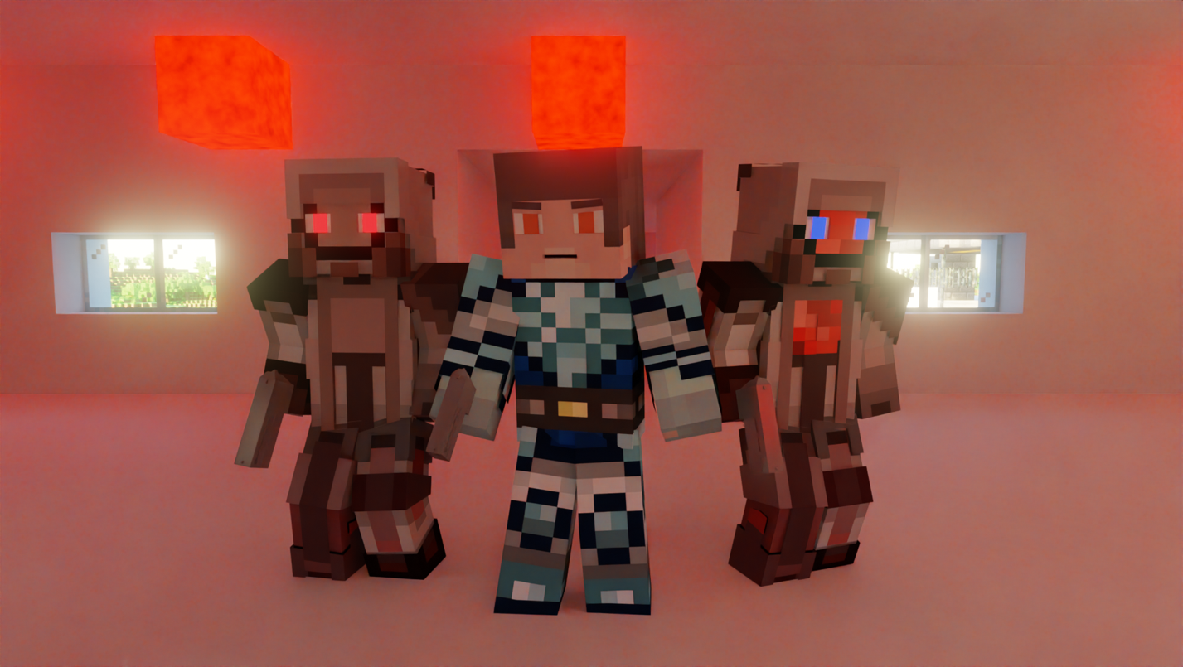

Prologue

There has been rivalry for years between the two troops Bayn and Osiris. These troops were not of any country and their bases were out of any country’s land. They fight each other without any rules or regulations.

Chapter 1

Date: July 2,2025

Location: Osiris base

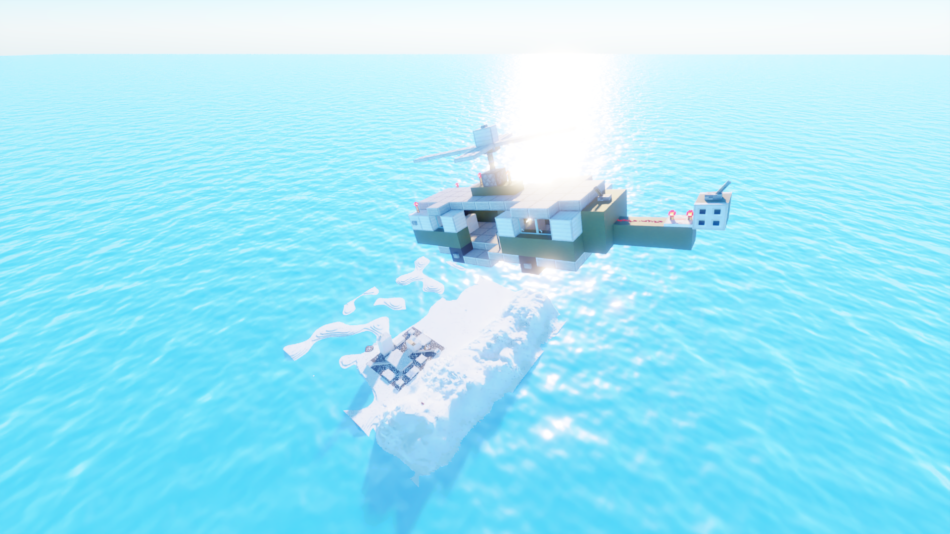

Osiris commander over comm: For the last 5 days 2 groups of Osiris soldiers have been killed at the border and there are even reports of bayn soldiers spotted.

Captain: They are very well trying to know our strength or size .….. or both.

Commander: So, what are you thinking to do?

Captain: Commander, fireteam Orion lost one of their soldiers when his airplane was attacked. I’m thinking to deploy S 117, Kabe as fireteam Orion’s new member.

Commander: Sure, I’ll get it done.

Chapter 2

Date: July 3, 2025

Location: Osiris base

Kabe enters the room where all members of fireteam Osiris are.

Kabe: Sir.

Dina: So that’s the new one.

Clint: Okay fireteam Orion load up we are going to the border.

Dina: And the new one?

Clint: he’s coming with us.

In the helicopter on their way to the border.

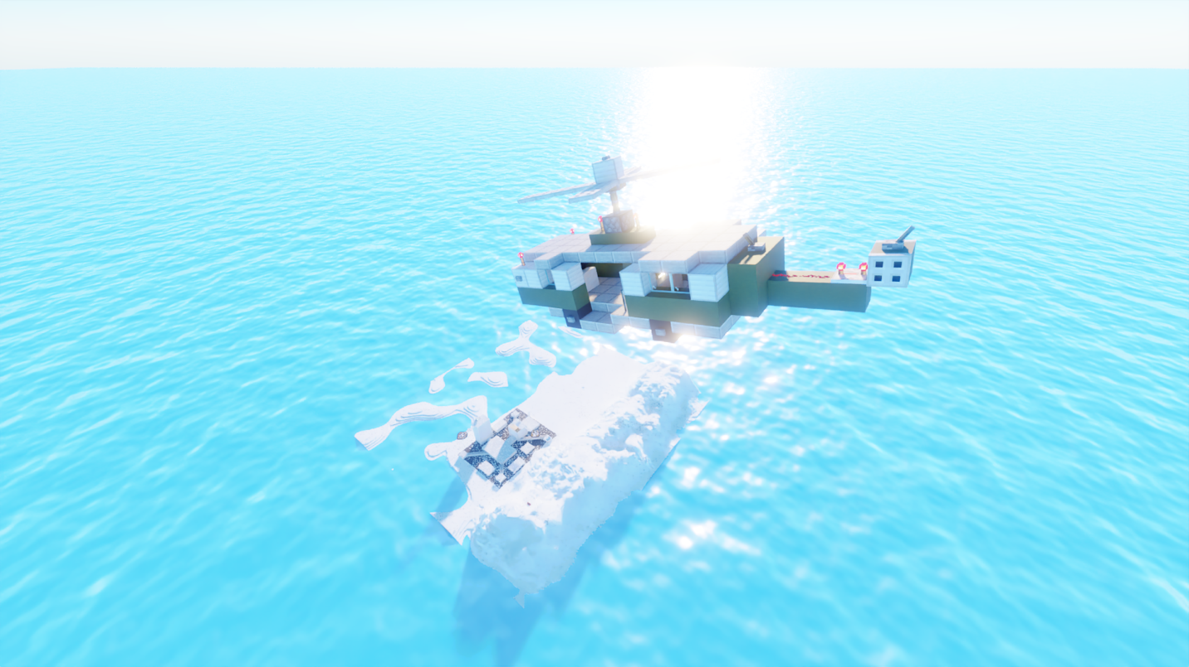

Clint: I read your file Kabe except the ones Captain didn’t want me to, Osiris keeps things very classified with us too. You’ve done great work, but the solo stuff stays down we’re a team now.

Kabe: Understood.

Chapter 3

Date: July 3, 2025

Location: Osiris borders

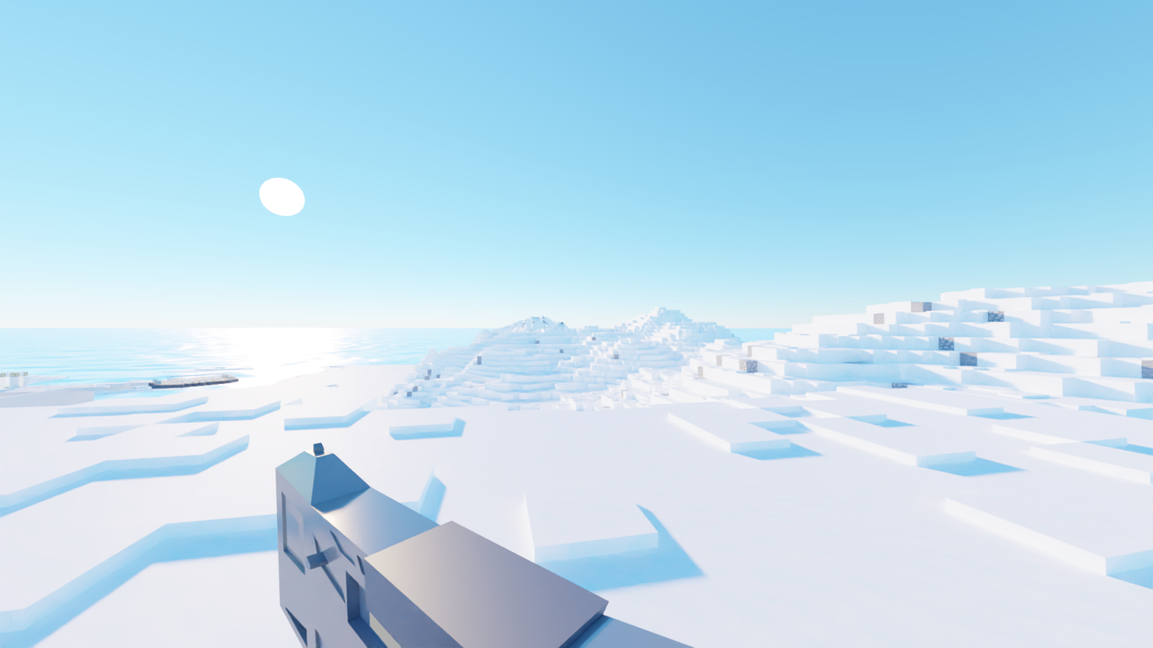

Clint: Okay fireteam Osiris we are to guard this part of the border and if you see anything or anyone pointing a gun towards you, shoot it.

All: Understood.

Clint: Sorry no we need to capture it.

John: Understood that too.

Time: 24:15

Clint: Is the tent ready?

John: Yes sir.

Fireteam Osiris spend the night in a tent at the borders waiting for the morning.

Chapter 4

Date: July 4, 2025

Location: Osiris border

John: So, did anyone survive from the attack at the border before?

Kabe: As far as I know, no.

Dina: Eyes out and stop talking, I hear something.

Kabe: Osiris leader I see movement, there above the mountain peak. It’s a helicopter its dropping soldiers.

Clint: Hide and move towards the targets if they are bayn soldiers do not shoot them, we need to arrest them they might have useful information for Osiris.

Dina: Sir they are bayn soldiers.

Clint: Try to arrest them.

John: Sir they got hold of our car.

Clint: John blows up the car, Dina alert the commander and then we will arrest them.

John blows up the car and the Bayn soldiers fall on snow.

Kabe hits the Squads leader on his head, and he falls unconscious while the other two Bayn soldiers are captured and three of them are taken to a jail in Osiris base.

Chapter 5

Date: July 4,2025

Location: Osiris base

Commander: Sir fireteam Orion has just caught three Bayn soldiers. They found them on the border trying to get into the base, we even found a bomb with them. It’s a really powerful bomb capable of mass destruction.

Captain: That’s even worse they are trying to wipe us out of existence already. Commander, I need you to question the captives about what they were trying to do.

Commander: And then should we kill them?

Captain: No! keep them as captives.

Commander: Affirmative.

Chapter 6

Date: July 4,2025

Location: Osiris base

Anonymous soldier: Sir! The prisoners they escaped.

Captain: Escaped?

Anonymous soldier: Yes, while we were bringing them for questioning they killed our soldiers and escaped. They are heading for the bomb. We brought them right in and let happen what they wanted.

Captain: Summon fireteam Orion I want them to kill the prisoners…….

The bomb blasted by the prisoners killed everyone except the ones who were far away but they died too when the building collapsed on them. Everyone except Kabe, He luckily survived even after taking a few hits.

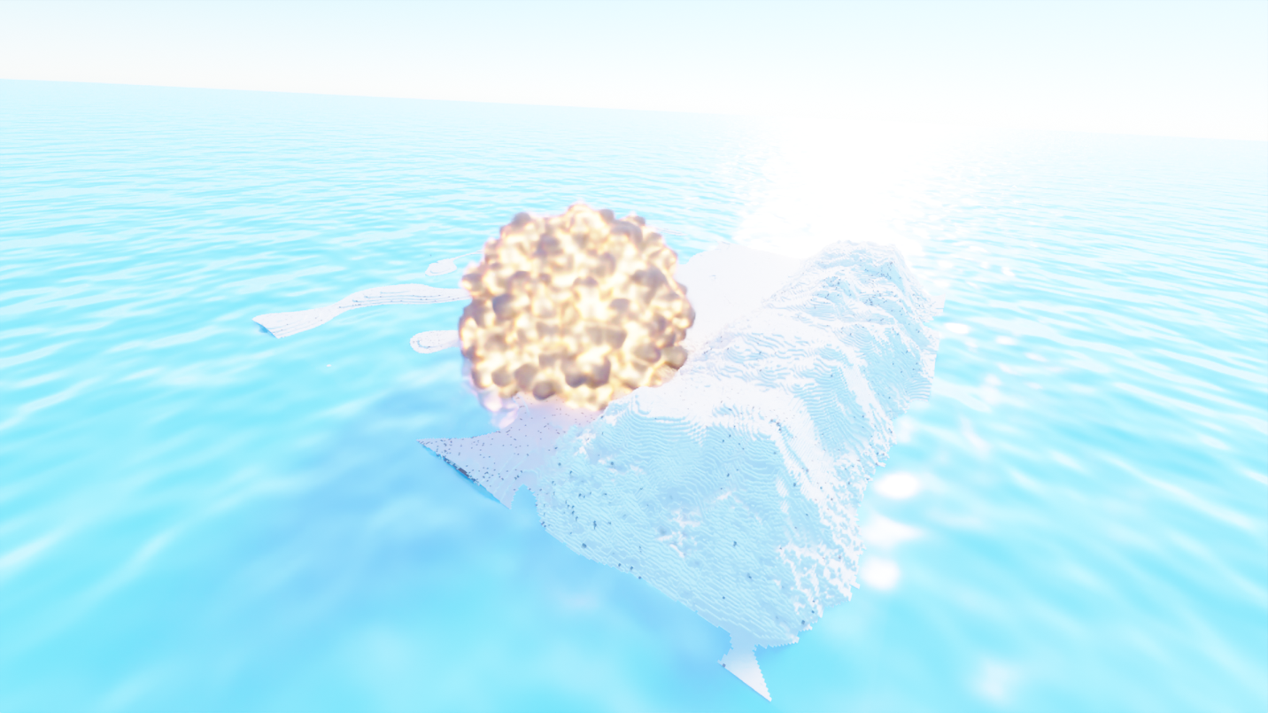

Continued in Squad 2:- <https://youtu.be/NVd8ao6HHBI>

The End